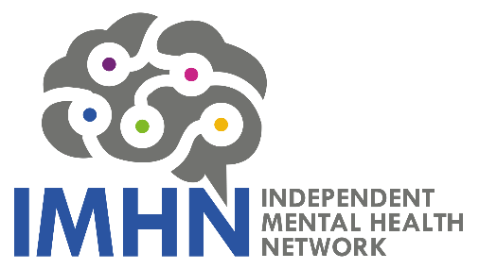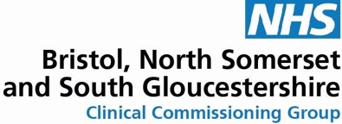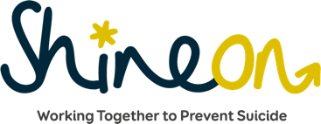

Apply for the Bristol, North Somerset and South Gloucestershire Suicide Prevention Innovation Grant Fund

What is the Suicide Prevention Innovation Fund?
This innovation grant is to support new or emerging projects with a small pot of funding designed to prevent suicides, save lives and reduce self-harm in Bristol, North Somerset and South Gloucestershire (BNSSG).

Applicants can apply for one-off funding grants of up to £250 towards their project (or up to £500 where it is across BNSSG). There is a total funding pot of £4,500 available.

We are looking, in particular, for imaginative and innovative projects which aim to reduce the numbers of suicides in:
- middle aged men
- men and women aged 16-25
- BAME communities
- LGBTQ+ communities
- Disabled communities
The funded projects will contribute to the overall BNSSG aim of reducing suicide rates.

Who can apply for the Suicide Prevention Innovation Fund?
Any individual or constituted organisation can apply. It is anticipated that the majority of funding will be awarded to community groups, small charities, individuals with an innovative idea and the voluntary sector.

We know that in the right hands, a little can go a long way, so we want your ideas about how to save lives across BNSSG.

What will not be awarded by the Suicide Prevention Innovation Fund?
The innovation fund will not support:
- requests for attendance at training courses, attendance at Training for Trainers courses, or the development of training courses. Should you have any suicide prevention related training needs please contact: engagement@imhn.org
- projects to support those bereaved by suicide. If you have an interest in this area, please contact: engagement@imhn.org
- projects that are ongoing. The innovation fund is for new projects.
- projects lacking innovation. The innovation fund is looking for imaginative, creative projects that do not duplicate already existing projects.
- staff costs
- capital expenditure (e.g. laptops)

Set Outcomes: guidance on completing your application form
While completing your application form please consider the set outcomes you hope to achieve such as the impact your project will have, how it will be delivered and how it will involve the people it is trying to support. Please also consider whether your project is sustainable when the funding has ended and how you plan to evaluate it. Successful applicants will be required to monitor the outcomes they expect to deliver, give monthly updates by phone, produce a final report and produce at least one publishable qualitative case study demonstrating the project’s impact.

What happens if I am successful?
You will be contacted by a member of Independent Mental Health Network (IMHN), to discuss your project and sign a short agreement. Your organisation would be required to raise an invoice in order to do this. If you anticipate any difficulties with this, please contact Tom Renhard on tom@imhn.org

Review of bids

Please note, bids will be reviewed as they are received. We have a limited pot of funding and priority will be given to those targeted at priority groups mentioned above.

Completion date
All successful projects must be completed by Spring 2020 unless agreed otherwise.

How do I submit my application form?

Please submit your application form to: engagement@imhn.org
If you have any issues with submitting your application, please email the IMHN team on engagement@imhn.org

Any questions?
If you have any questions about the Suicide Prevention Innovation Fund, please email Tom Renhard on tom@imhn.org
Application form
The information you supply will be sent to a panel of representatives including Community Access Support Service (CASS), IMHN and South Gloucestershire Public Health and will only be used only for the purpose of applying for the Suicide Prevention Innovation Fund.

About you
Title: |  | First name:
Last name: |  | Organisation:
Role: |  | Phone:
Email: |  | Address:
If you work for an organisation, please let us know who is sponsoring you for this – for example your line manager or director.

Please make sure you discuss this with them beforehand and let us know their contact details below:
Organisation:
Name: |  |  | Role:
Email: |  |  | Phone:

About your idea
Tell us about your idea which aims to reduce the numbers of people dying by suicide and rates of self-harm in BNSSG.
- What is your project? Briefly describe the idea you have (max. 500 words):
Name of your idea:

Date it will take place:

Where will it take place:

What is your idea about:
- Why is it needed? (max. 200 words)
- Does anything else exist like it? (max. 200 words)
- How will it be delivered in your local area? (max. 300 words)

Note: local area could be a neighbourhood, ward, locality, local authority area.

- What are the projects bespoke objectives? (max. 300 words)

- How will you know you have achieved the set outcomes and the bespoke objectives? (max 300 words)

- How do you plan to evaluate your project? (max. 300 words)
(Successful applicants will be required to monitor the outcomes they expect to deliver, give monthly updates by phone, produce a final report and produce at least one publishable qualitative case study demonstrating the project’s impact.)

- How much funding are you applying for? Please provide a brief breakdown of the costs for your project:

- Please confirm you are happy for your idea / event to be included in our booklet that will promote the suicide prevention campaign taking place in November should you be successful:

Yes / No (Please delete as appropriate)
Submit your completed application form to: engagement@imhn.org

Please note, bids will be reviewed as they are received.

If you have any questions about the Suicide Prevention Innovation Fund please email the IMHN team at engagement@imhn.org

The Fund is supported by the Suicide Prevention Transformation Working Group. This is a partnership of organisations that include:

- Avon and Wiltshire Mental Health Partnership NHS Trust
- Bristol City Council
- Bristol North Somerset & South Gloucestershire Clinical Commissioning Group (BNSSG CCG)
- Community Access Support Service (CASS)
- Independent Mental Health Network (IMHN)
- North Somerset Council
- Public Health England
- Second Step
- South Gloucestershire Council
- University of Bristol
- University Hospitals Bristol NHS Foundation Trust

